DOCUMENTATION SAMPLE SHEET

**1. DEVELOPMENT CHOICE: ___vs code_ (sublime/php storm/vs code/others ?)**

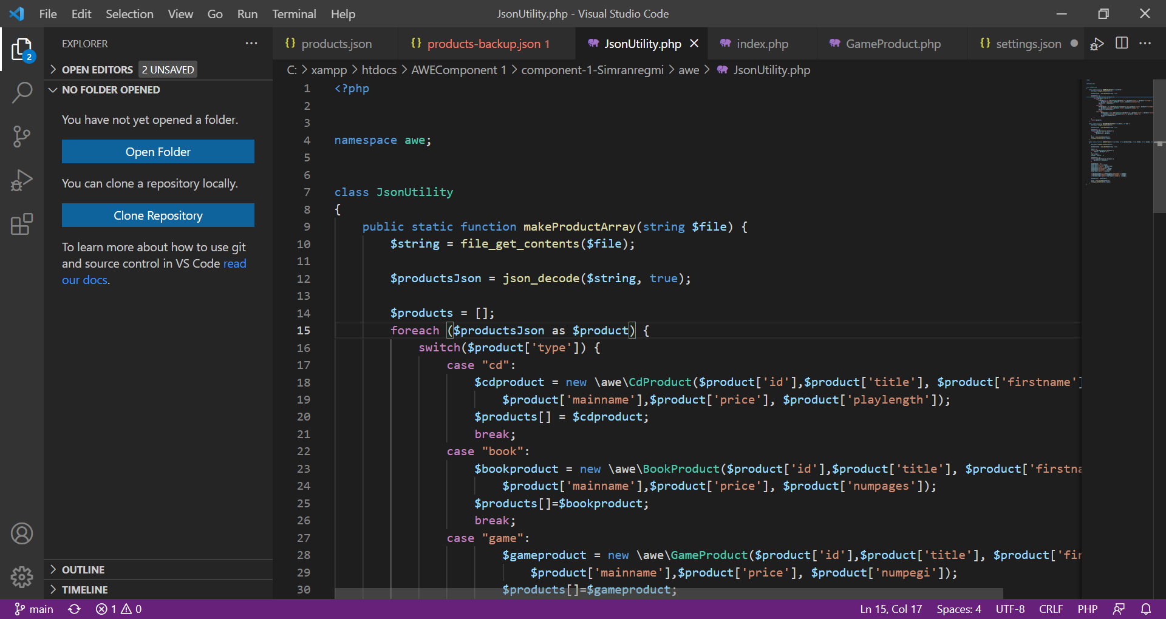

**2. PHP VERSION being used: _8.0.12____ (**fill with the php version in your system/xampp)

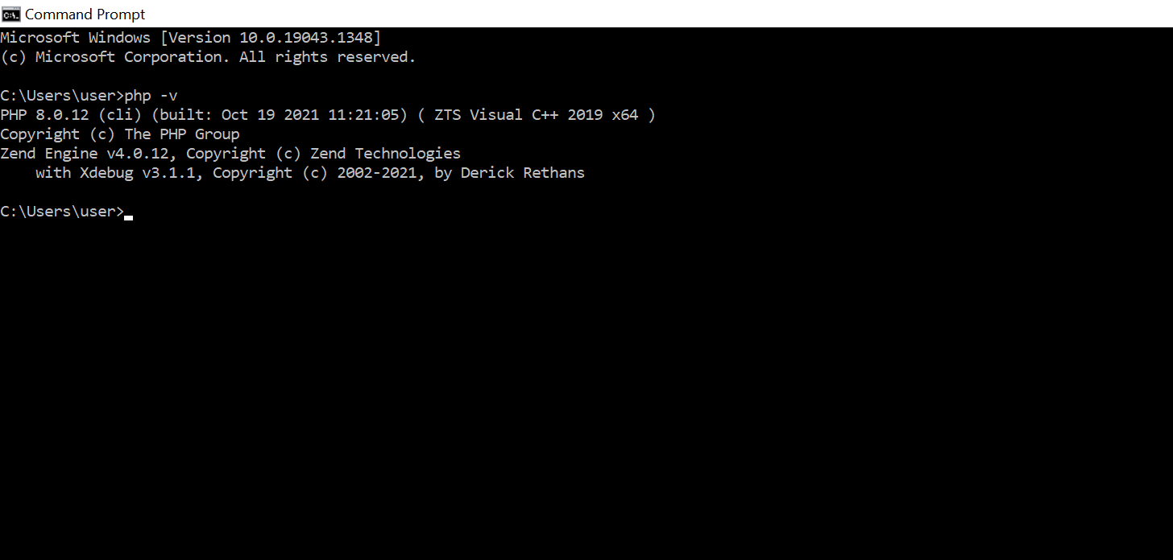

**3. Github account component 1 repository link: ____**(your component 1 repo link here)

https://github.com/Simranregmi/COMP-1-AWE.git

**4. PHP Exercise in component 1 completed? __yes___ (yes, no, partial)**

